REACT JS, NODE JS, MONGODB, MYSQL QUICK GUIDE

Table of Contents

Declaring routes in ReactJS 2

MULTISTEP IMPLEMENTATION IN REACTJS 3

TAILWIND CSS 4

## Declaring routes in ReactJS

The important tool for creating declarative routing is the React Router DOM.

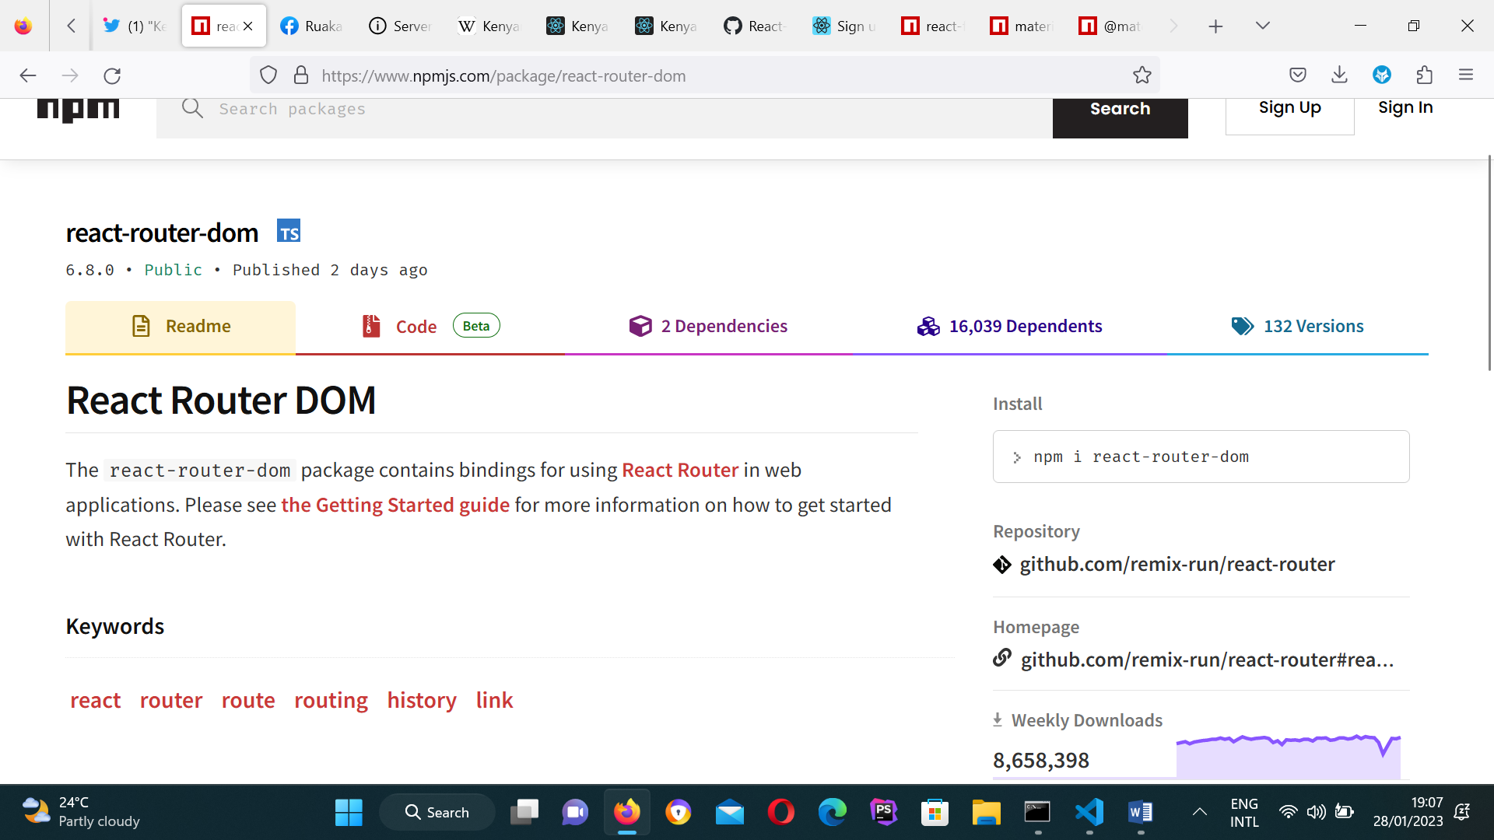

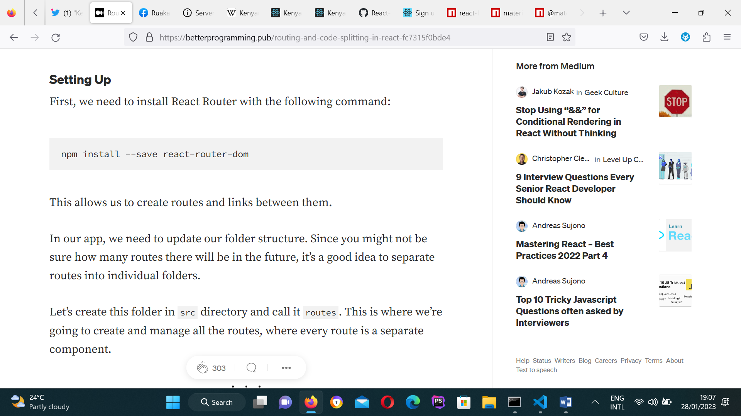

## MULTISTEP IMPLEMENTATION IN REACTJS

IMPORTANT MATERIALS

<https://github.com/majakochanowska/React-Multistep-Form/tree/master/src>

AND <https://modest-saha-db0481.netlify.app/>

# TAILWIND CSS

